Format string attack && Creating an exploit:

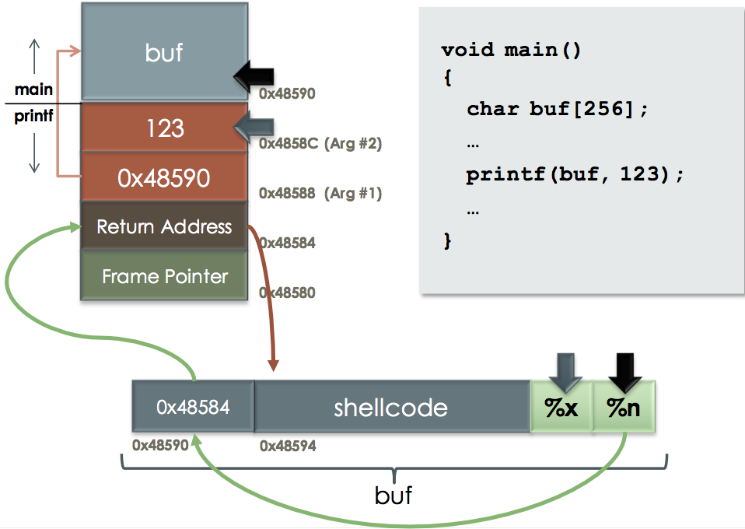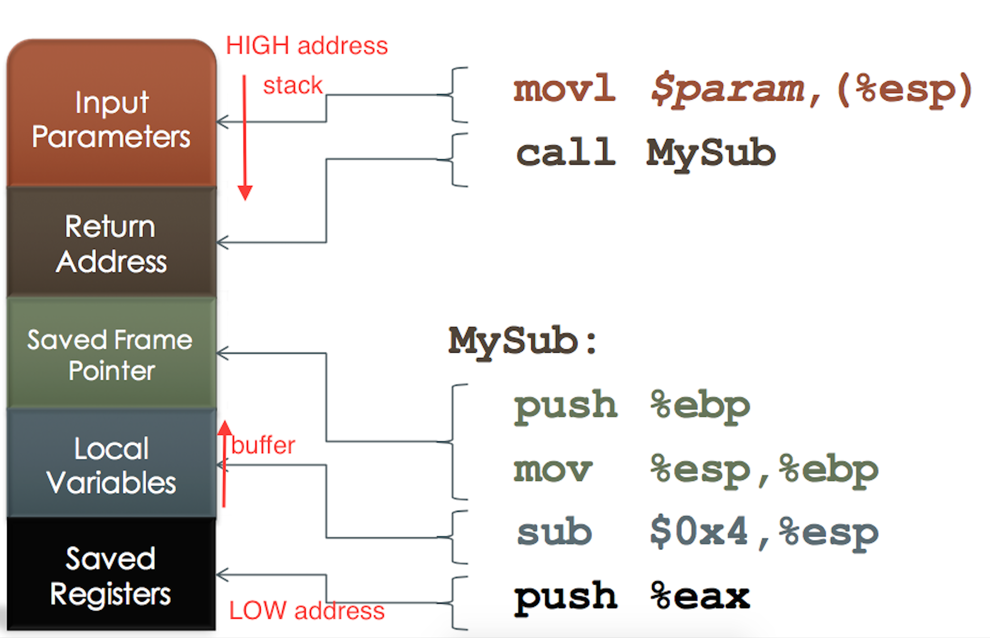

Overwritten the return address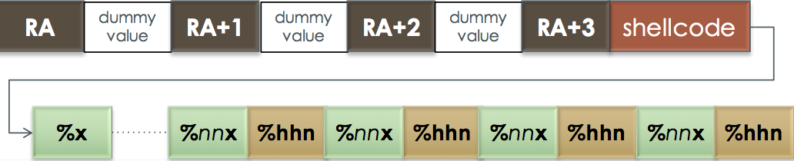

Double free

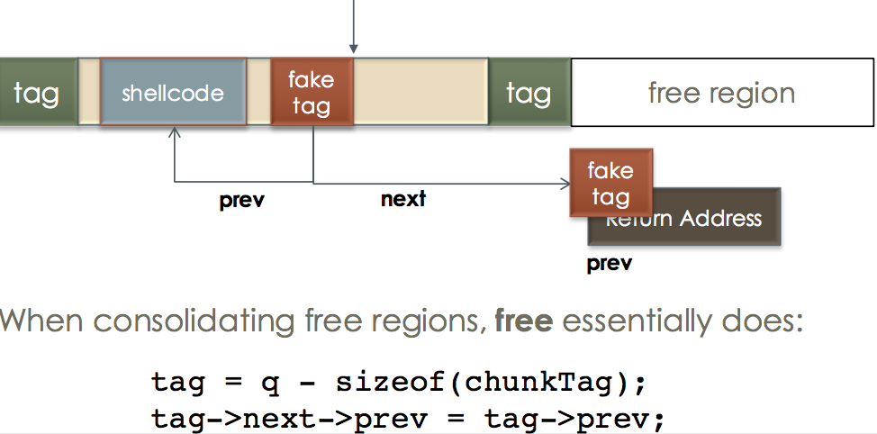

Defending Against Stack Smashing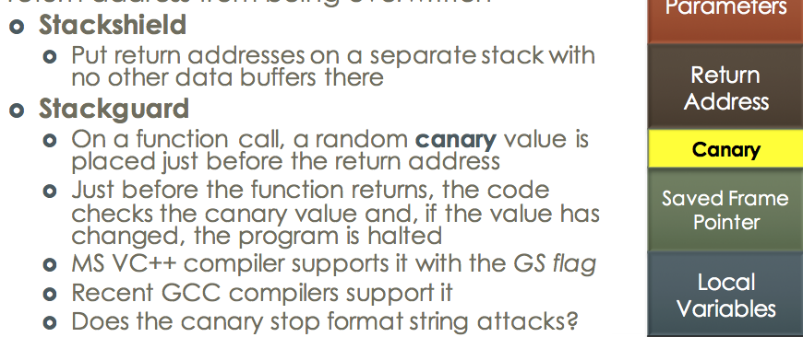

Return into libc

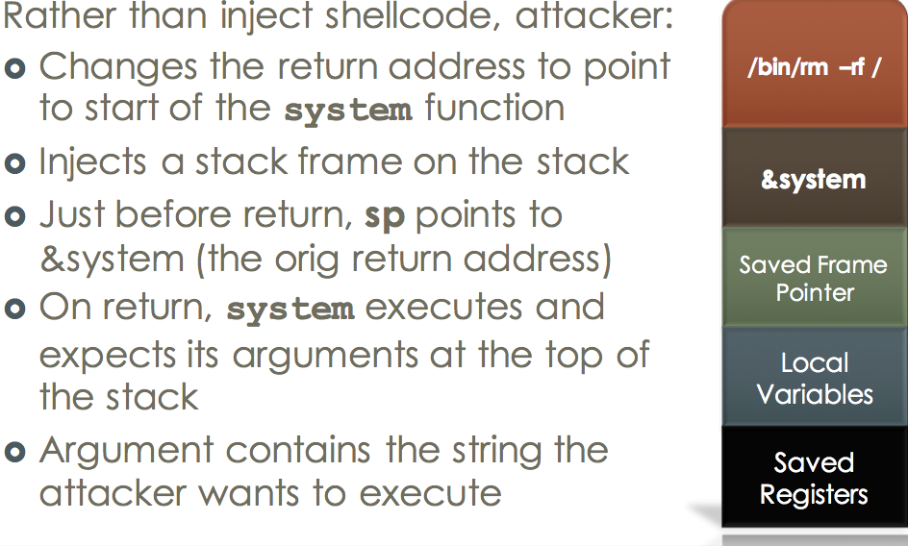 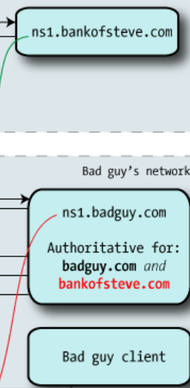

Dynamic link

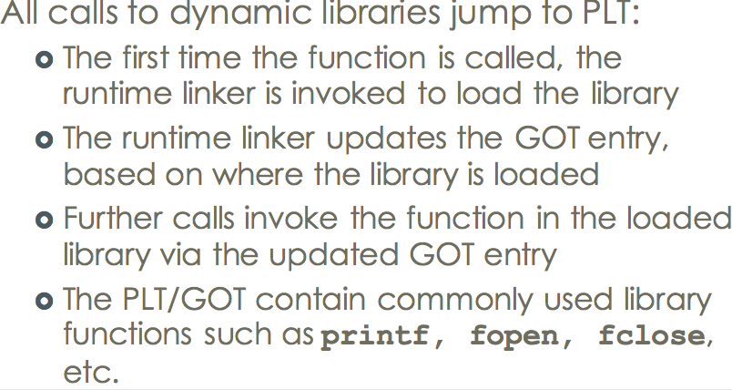

Address-Space Layout Randomization (ASLR)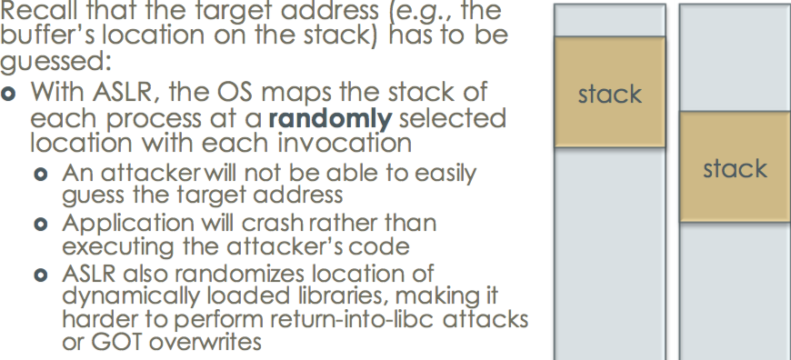

properties of Cryptography

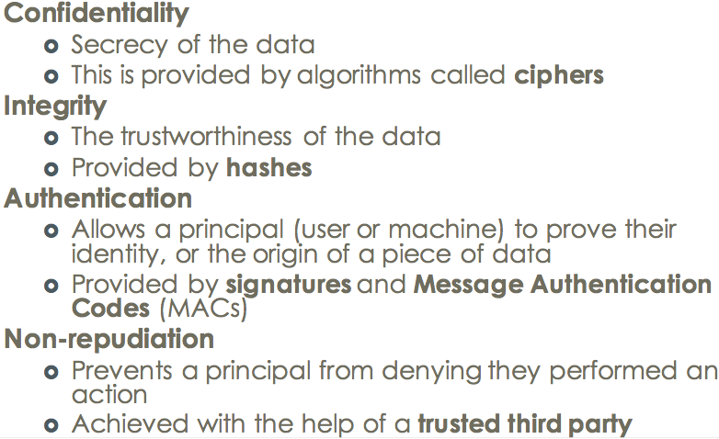

Polyalphabetic Cipher

One-time pad problem

1, Key length = message length (Key overhead of 100% is generally not acceptable )

2, Each key can be used once (hence the name)

3, Cipher is malleable

4, Ciphertext-only: (If used properly, impossible to break)

5, Known-Plaintext ›

Very weak / just XOR CT with PT to reveal the key /Only need one pair / Of course, key is not supposed to repeat

6, Chosen-Ciphertext/Plaintext -> weak

Block Cipher

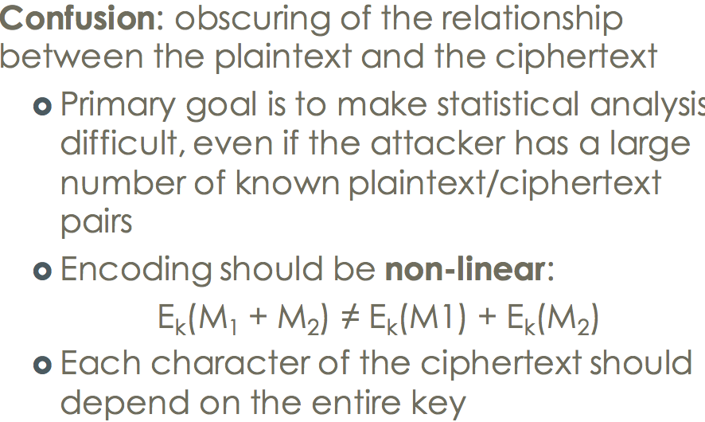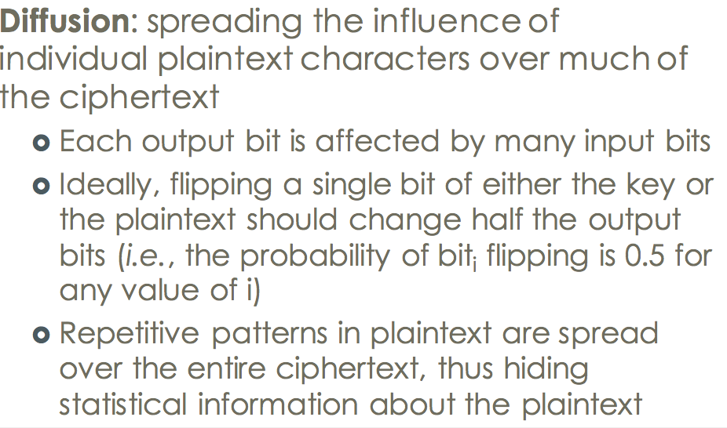

1, Substitution chiper is used for confusion purpose.(One-to-one mapping)

2, permutation cipher is used for diffusion(transposes the plaintext character)

DES: Data Encryption Standard

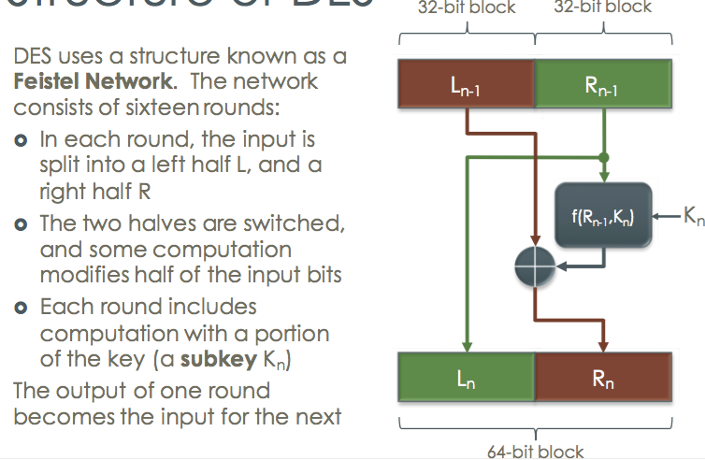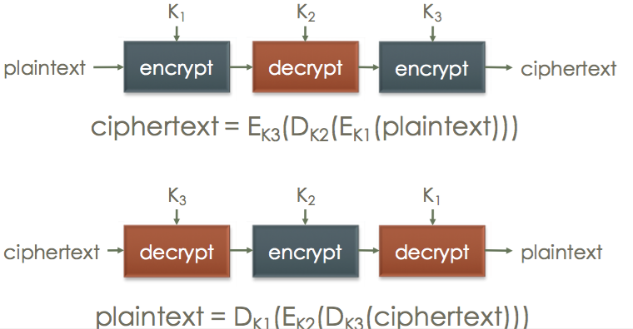

3DES splitting a 168-bit key into three 56- bit parts

and running the algorithm three times

ECB Electronic Codebook

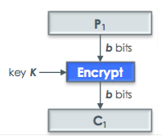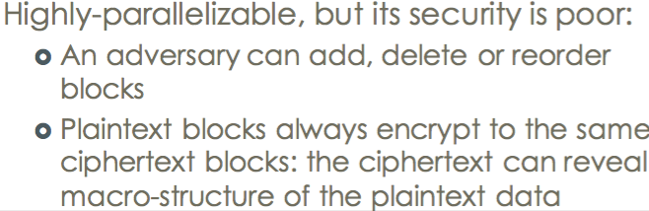

Cipher Block chaining (CBC)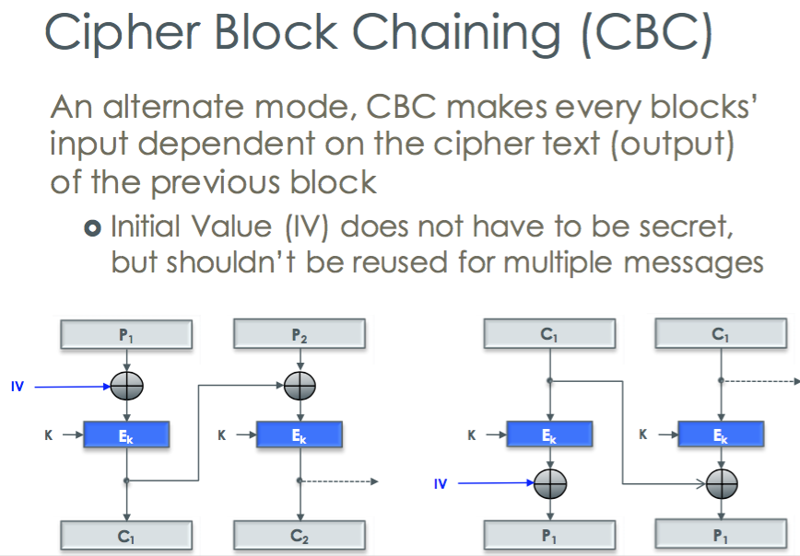

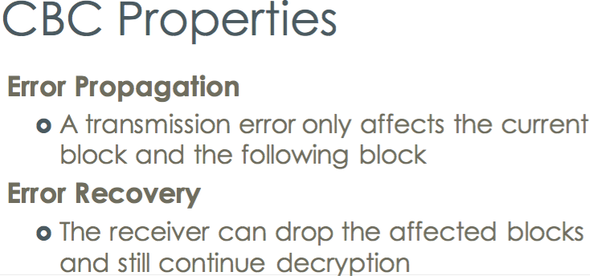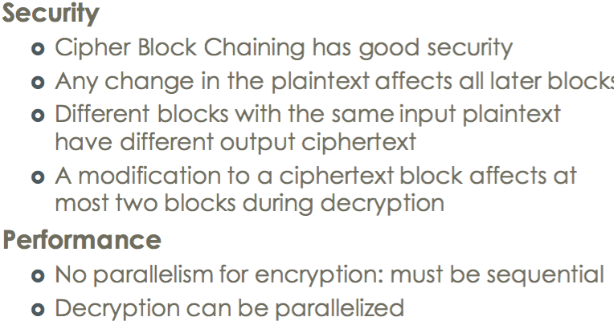

Cipher Feedback (CFB)

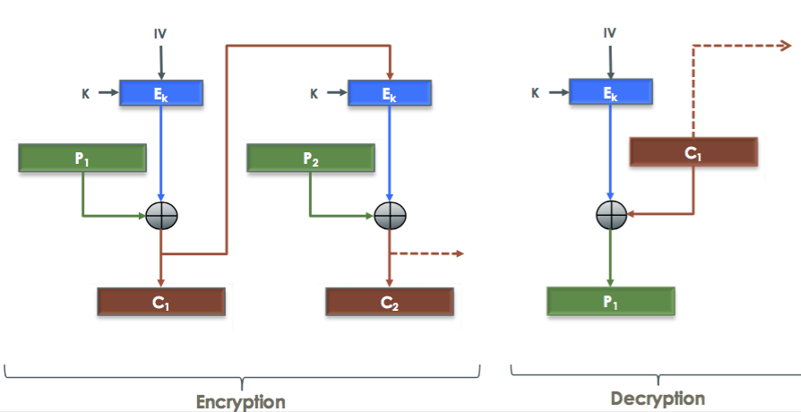

Output Feedback (OFB)

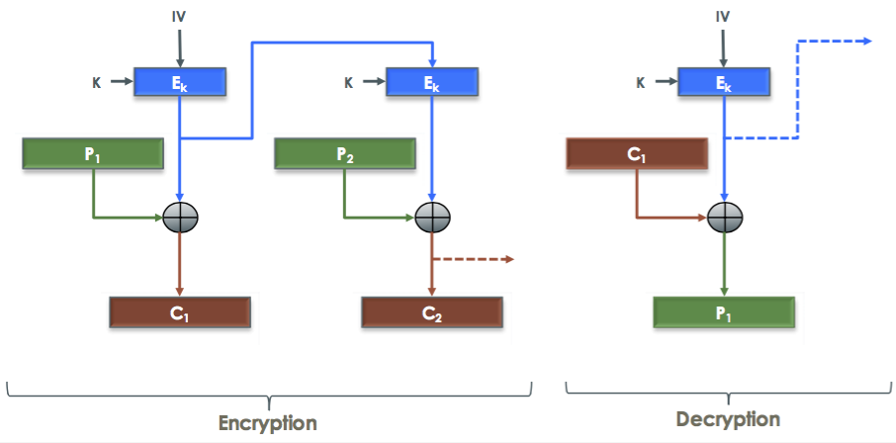

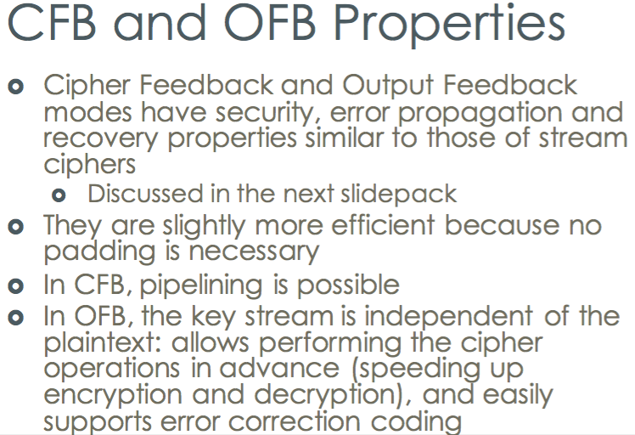

Stream cipher

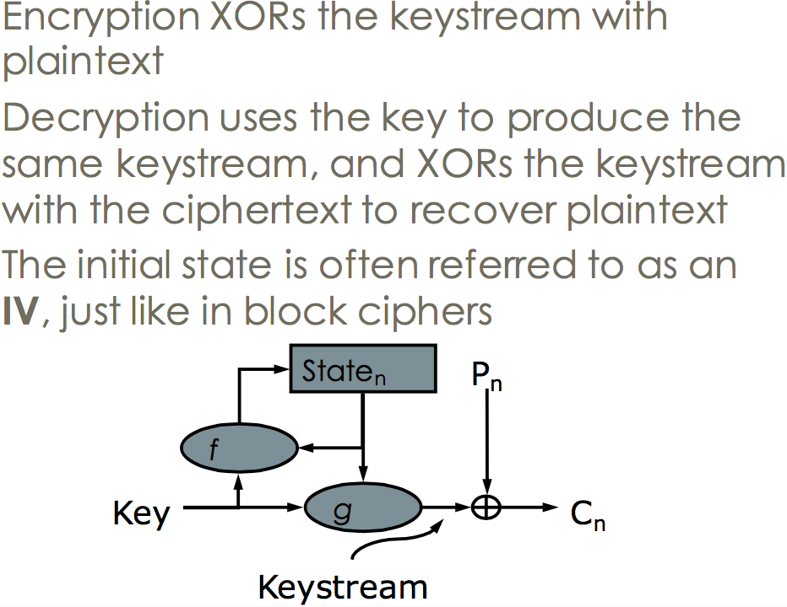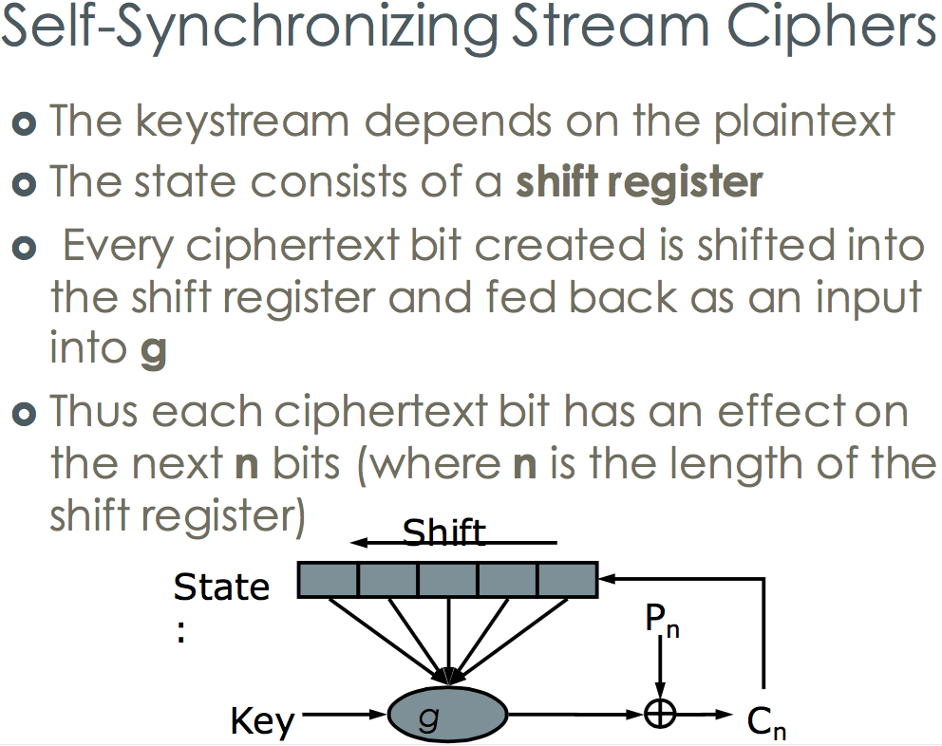

Security & Performance

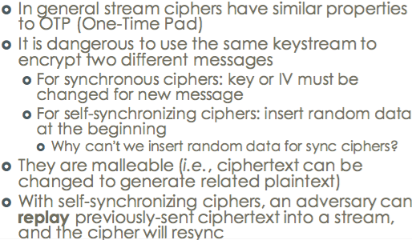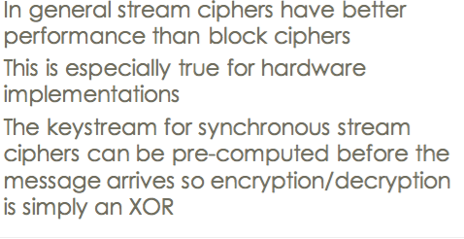

Error propagation && Error Recovery

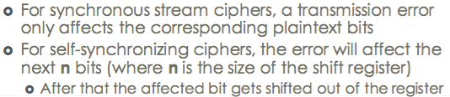

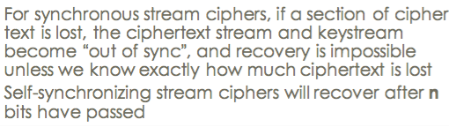

Needham-Schroeder Protocol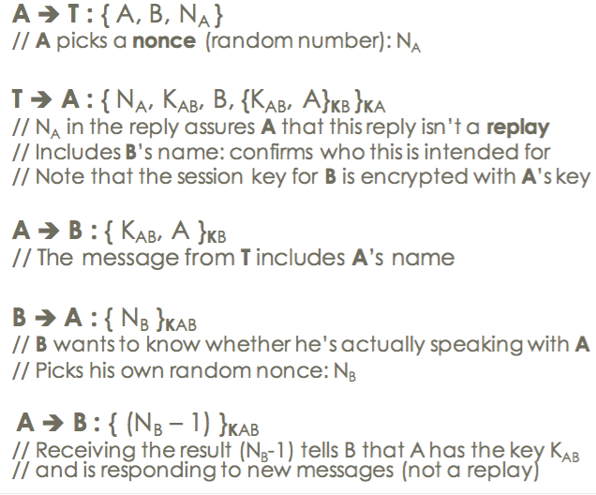

Diffie-Hellman Key Exchange

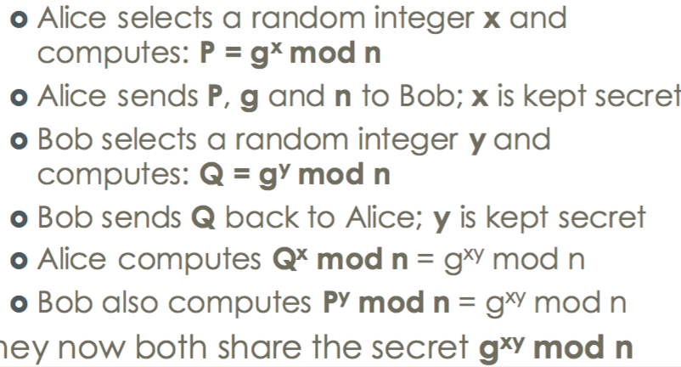

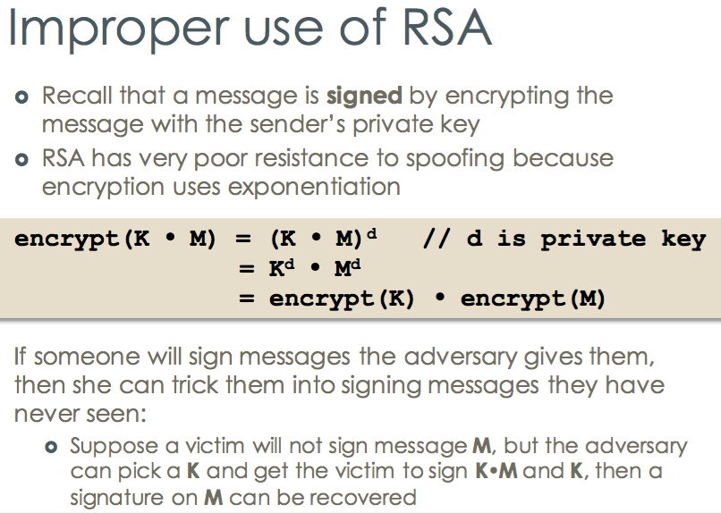

PGP: An Alternative to PKI

Message Authentication Code

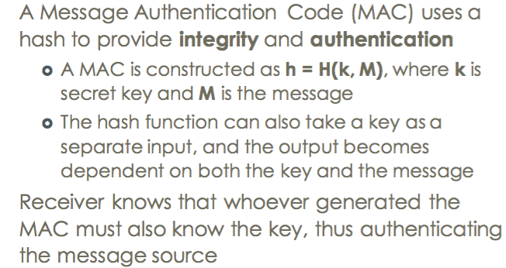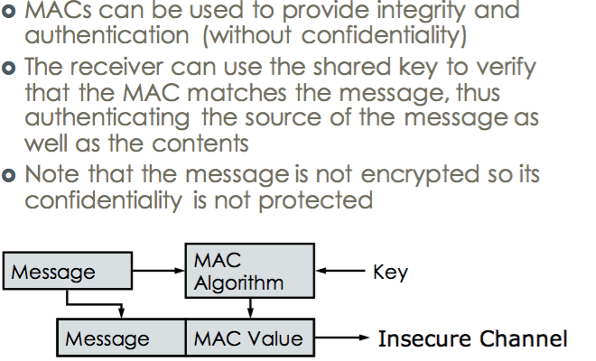

**MAC using Symmetric Ciphers CBC-MAC**

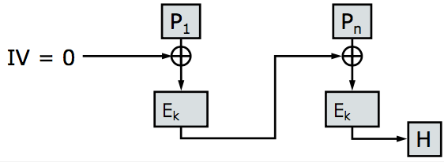

**HMAC**

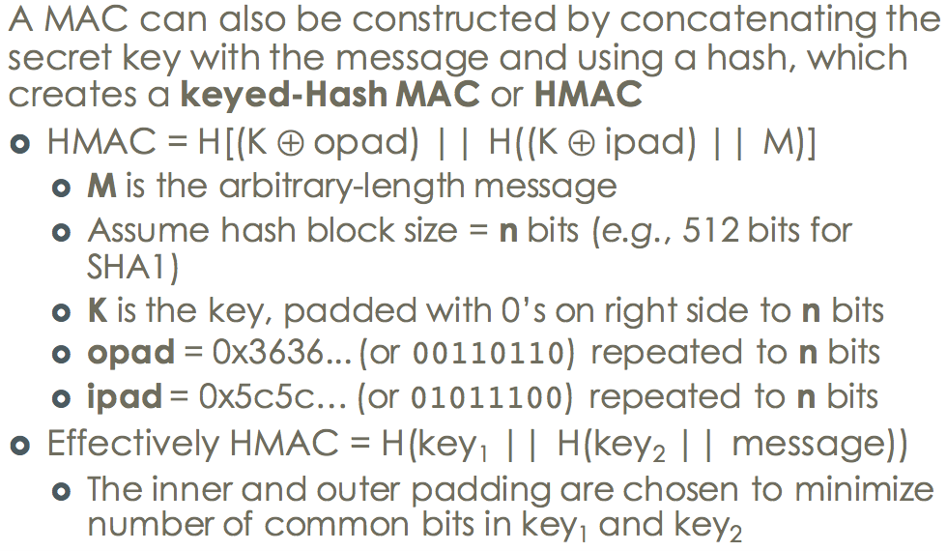

HMAC = H[(K ⊕ opad) || H((K ⊕ ipad) || M)]

**Solved problem(CBC -MAC):**- Simply concatenating the key with the message and

hashing is not secure. Since MDCs are iterated functions,

a single hash may allow an adversary to add arbitrary

information at the endof the message and compute a new

M Attacks against MACs:  
**Existential Forgery**: an attacker can create a valid text-

MAC pair, but without control over the text

**Selective Forgery**: An attacker can create a valid text-MAC pair

, with text of her choice

**Cryptographic Hashes**

**Preimage Resistance:** Given a hash value h and function

H, it is hard to find m such that H(m) = h

**2nd Preimage Resistance (2^(n-1)):** Given m, it is hard

to find an m’, such that H(m) = H(m’)

**Collision Resistance(The expected number to get the**

**answer -> 2^(n÷2)):** It should be hard to find collisions

(i.e., two pre-image values that coincidentally hash to the

same hash value), Hard to find any two m and m’ such that

H(m) = H(m’)

Replay attack

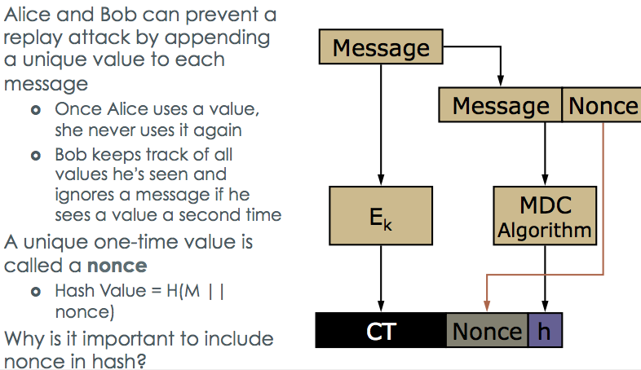

Reorder attack

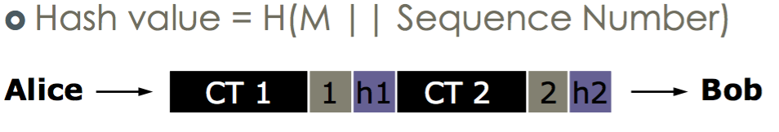

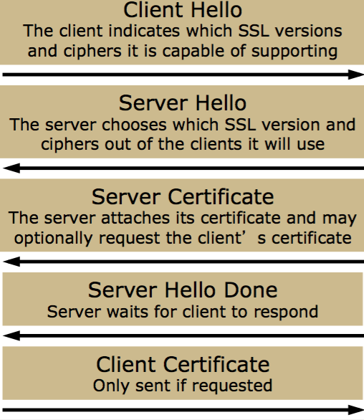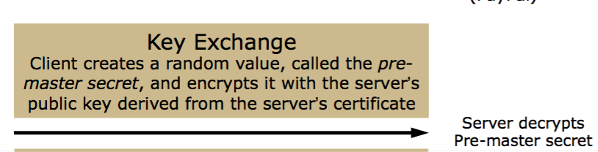Basic Web Cookie-Based Authentication

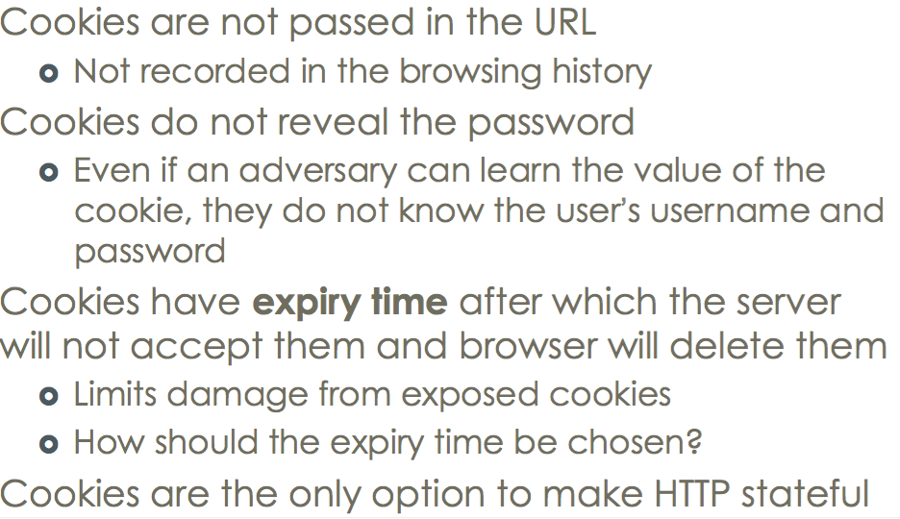

Cookie && SSL

Cookies should be used for authentication wit SSL, or else cookies can be easily stolen

.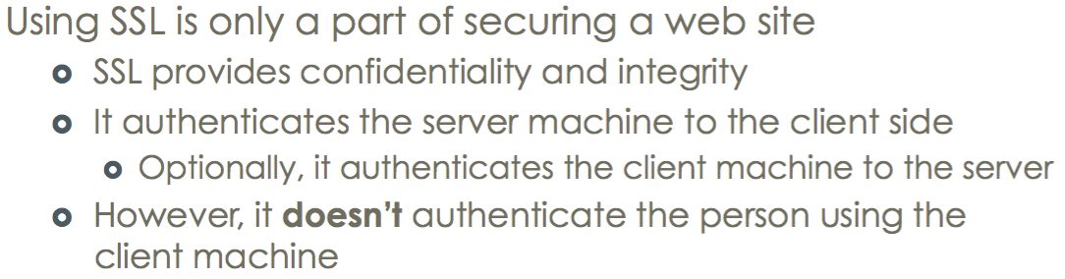

Stealing data && Same origin policy(Protection method)

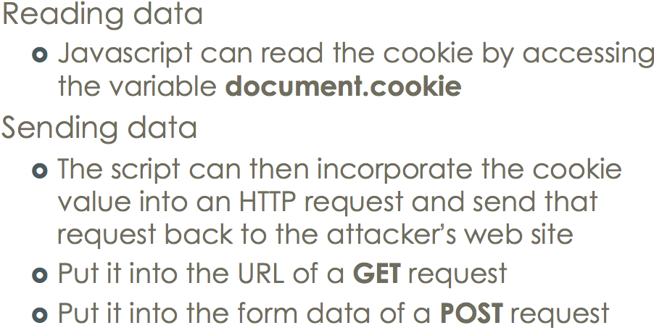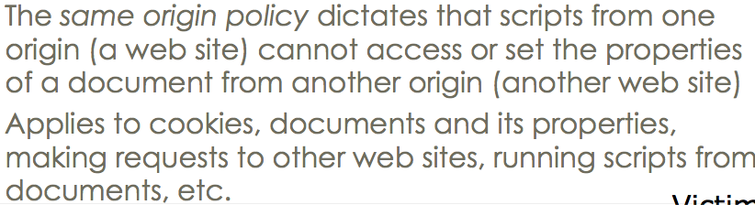

Define Same origin policy:

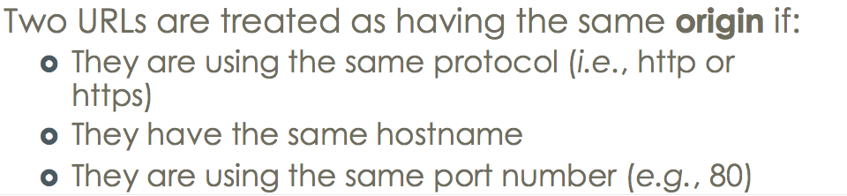

www.amazon.com and www.amazon.co.uk are not considered the same origin.

Cross-Site Scripting (XSS):  
User/Browser cannot **distinguish between legitimate script from web site and script injected into the web site by third party**

Result from **inadequate input validation** at a web site

**The same origin policy been violated? ›**

No: the script originates from the same site as the cookie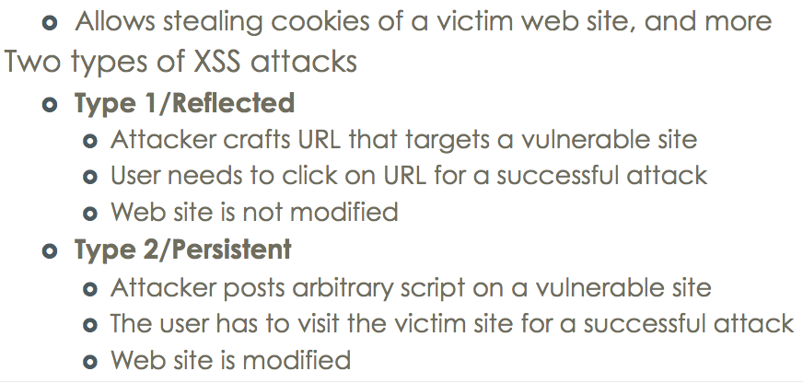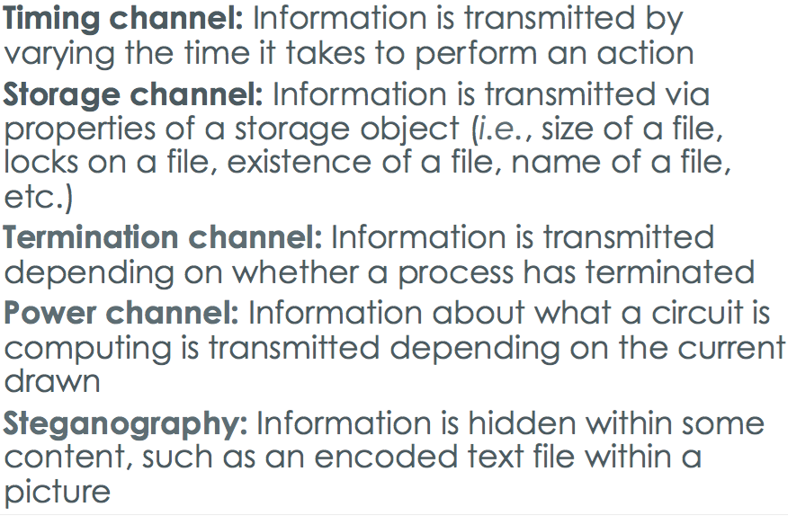

**Samy Worm**

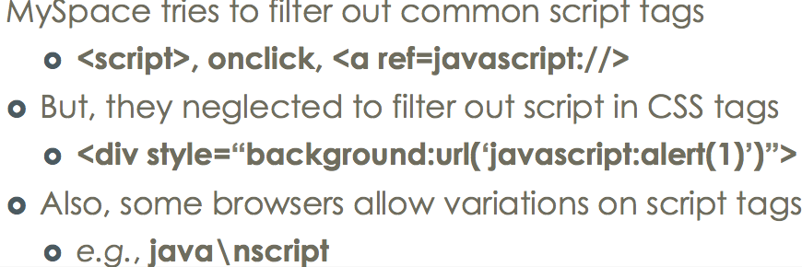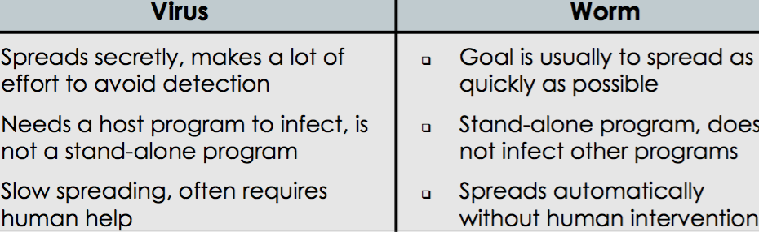

**Defenses Against XSS**

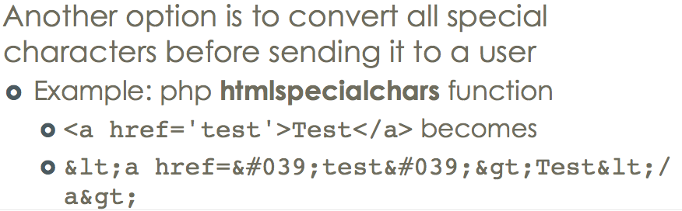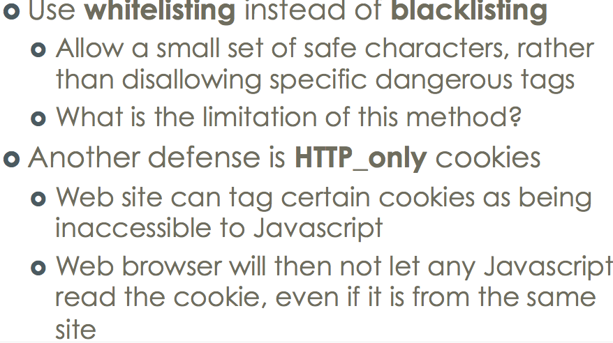

**HTTP Response Splitting && Cross-site request forgery**

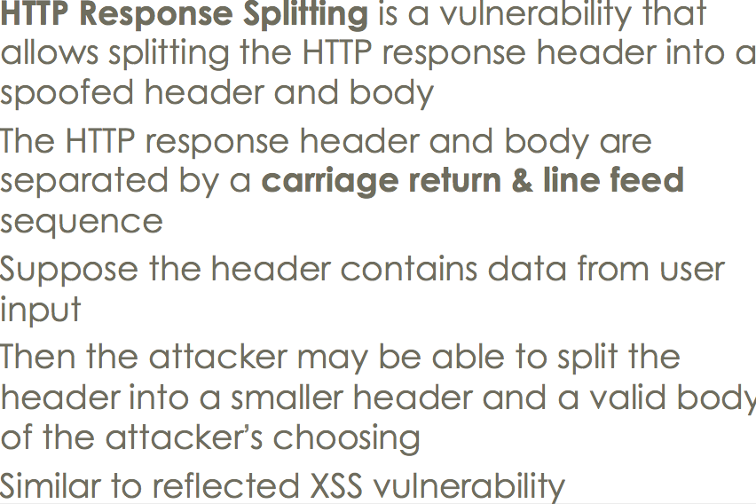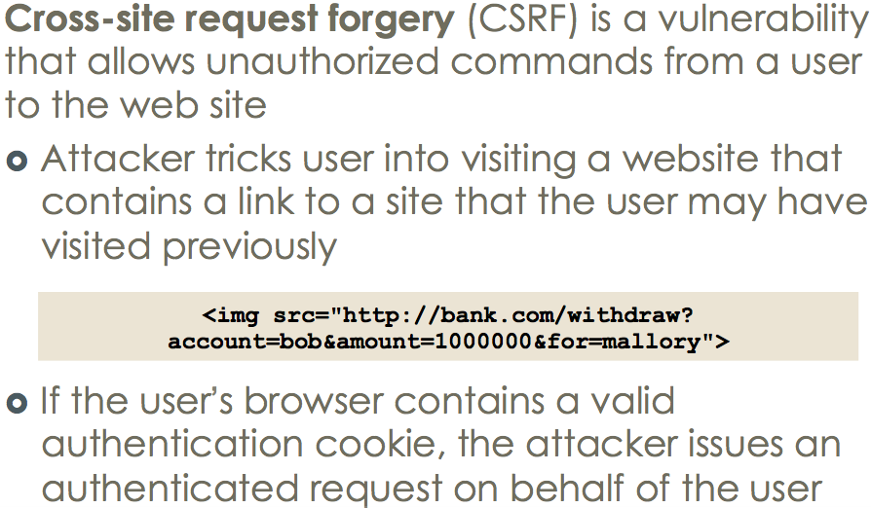

Web site cannot distinguish between **legitimate requests and unauthorized requests** from the user. Result from an attacker being able **to guess valid request**

**Defenses Against CSRF**

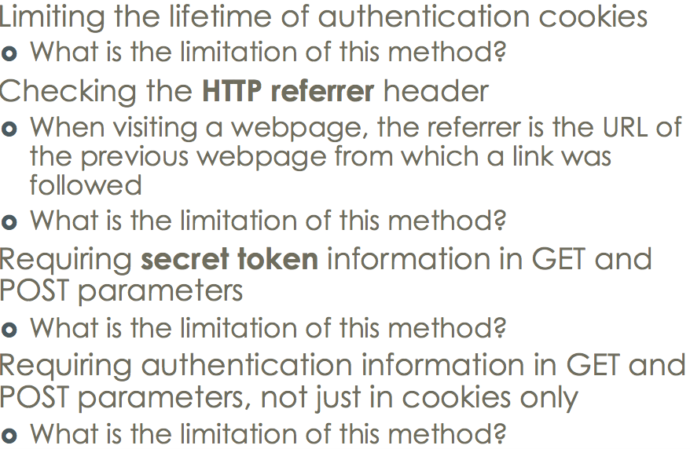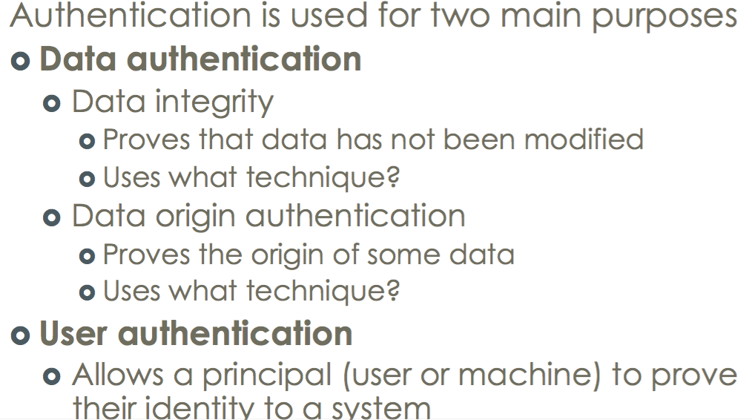

**Turing Test** use a CAPTCHA

Often a remote site wants to check whether there is a human on the other end

Access Control && enforcement mechanism

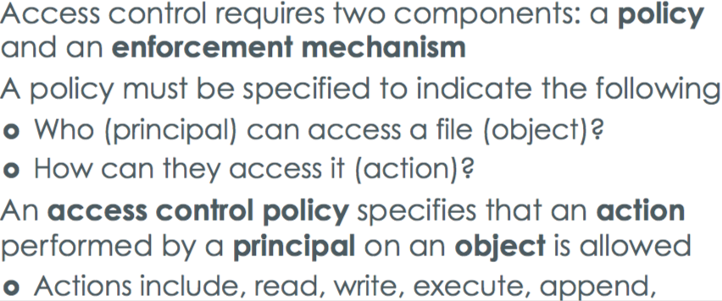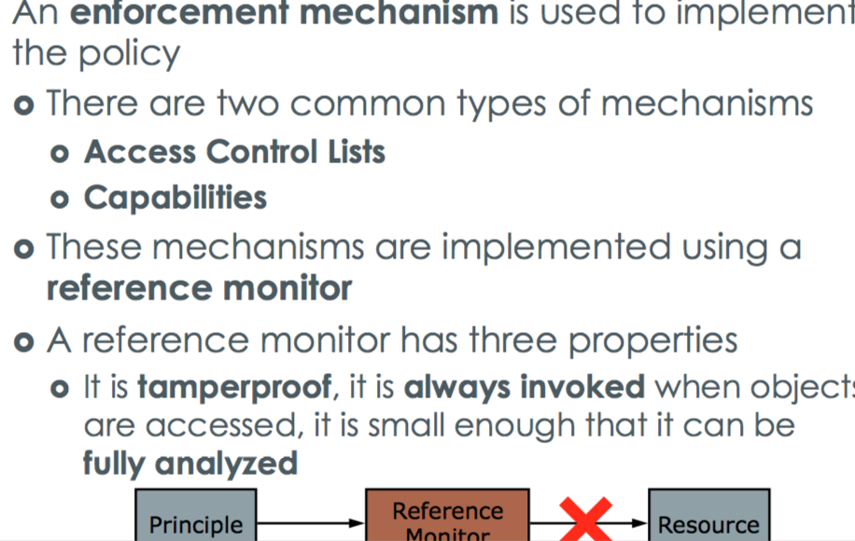

**Access Control Lists (ACL):** maintain the access control policy for each resource-files)

**Capabilities:** maintain the access control policy for each principal(users).

**An access control matrix:** stores the access control lists for several objects together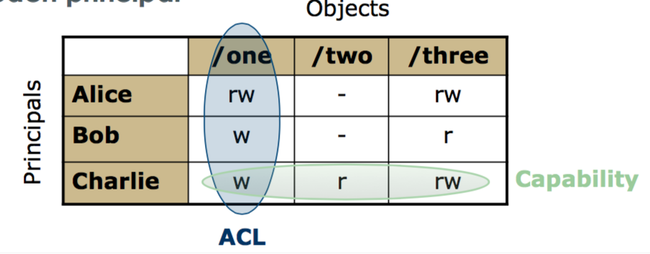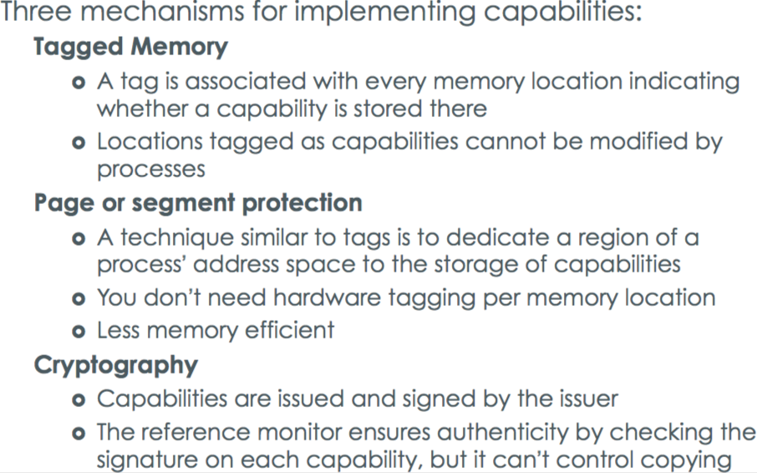

**Drop privileges** However, a program running with root UID can change its UID by invoking the Unix setuid call. FTPD can use setuid to drop root privileges and become another us **Gain privileges** a user can run a program as another user if the program

file has the setuid bit turned on . When a setuid executable is run, it runs with the UID of the owner of the file (rather than the user invoking the program)

**A Confused Deputy** is a buggy program that is fooled into misusing its privileges

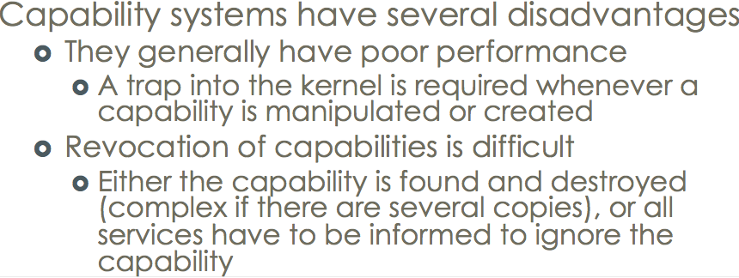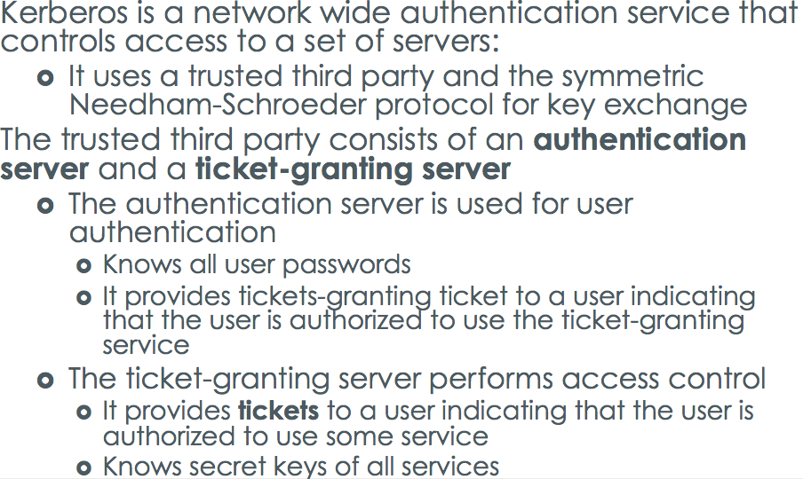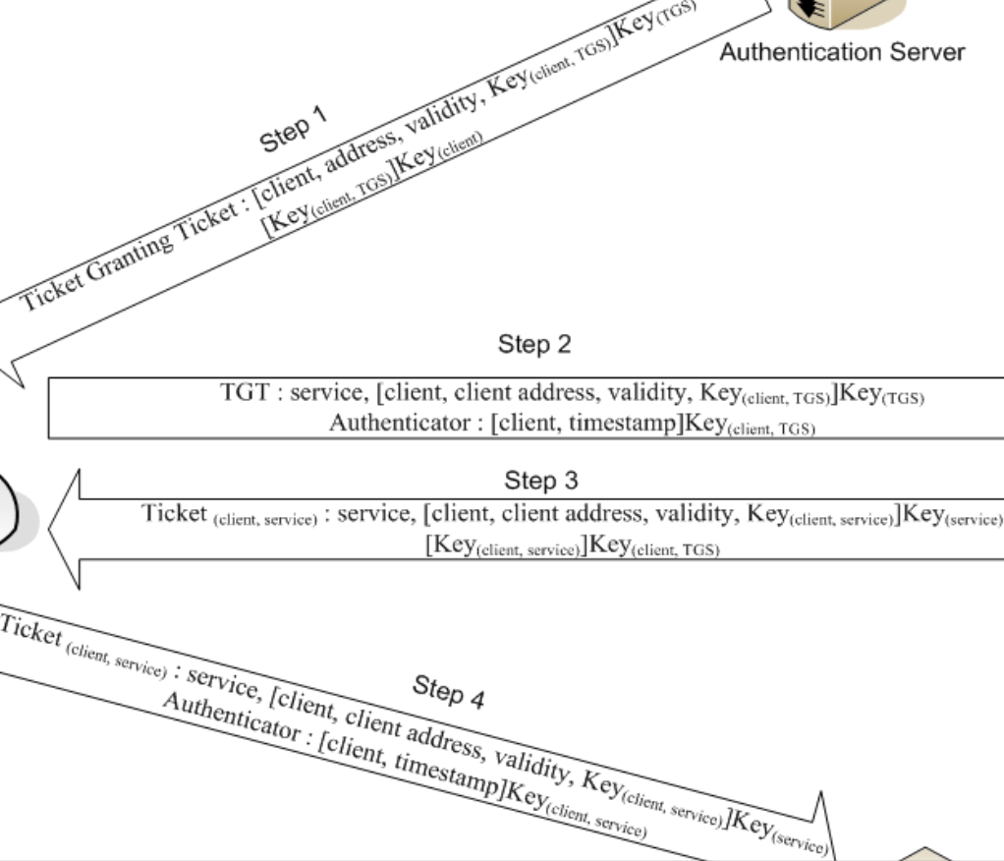

**Discretionary Access Control** (user may make mistake)Users are allowed to

alter the access control lists on objects

**Mandatory Access Control** (hard to configure)The system (oradministrator) sets up the access control lists and users have no control over changing the list, even for objects they own

**Role-Based Access Control** (treat users as groups) defines a set of roles with specific privileges, assigned by system Users have the ability to take on one or more roles system administrators to think about and assign privileges needed for a role

**Bell-La Padula (BLP) Model – Confidentiality(security)**

Subjects are active participants in the system

Objects are data or resources that need to be protected

**Simple Security Property (R)**A subject s can read an object o iff the security level of s dominates security level of o, and s has discretionary read access to o.Star Property(w)

**Biba Integrity Policy – integrity**

Simple Security Property(R) Star Property(w)

**Covert Channels**: allows implicit information flow, outside of the specified policy implying that information is sent intentionally, and the sender wishes to remain undetected With **side channels**,information leak unintentially

**Non-interference** allows analyzing convert channels A System has the non-interference property if any sequence of inputs to a process will produce the same outputs, regardless of inputs to another process

ARP attacking

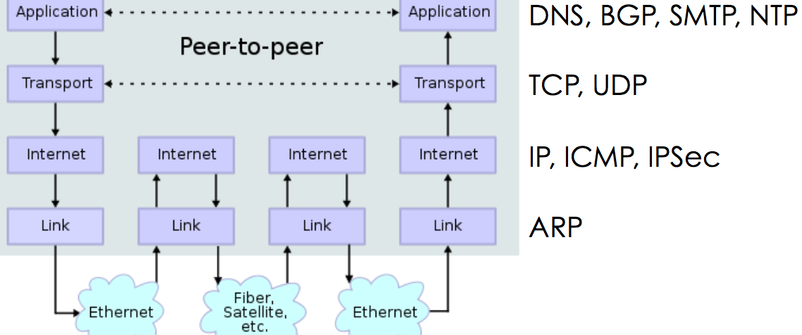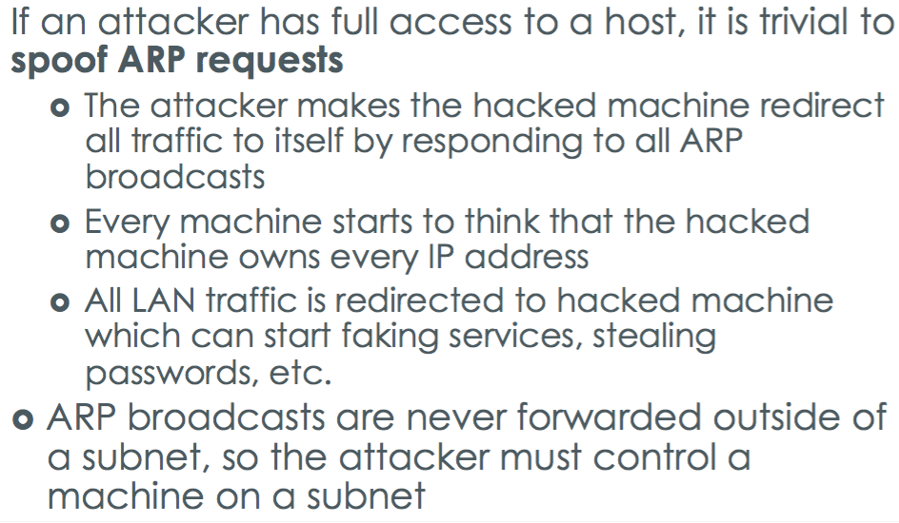

**ICMP “Smurf” Attack** A Smurf attack generates lots of network traffic, by flooding a victim machine with ICMP packets from many different machines

- An attacker sends a **ping stream**(ICMP echo requests)to an IP broadcast address with a spoofed source IP address of the victim machine.

- Every host on target network will generate **ping replies** (ICMP echo replies) to victim, overloading the victim

**Defenses**: At Host: Disable response to ping broadcast. At router/switch: Disable broadcast forwarding

**TCP Connection Spoofing** An attacker can forge a packet with the source IP address

set to the client’s address

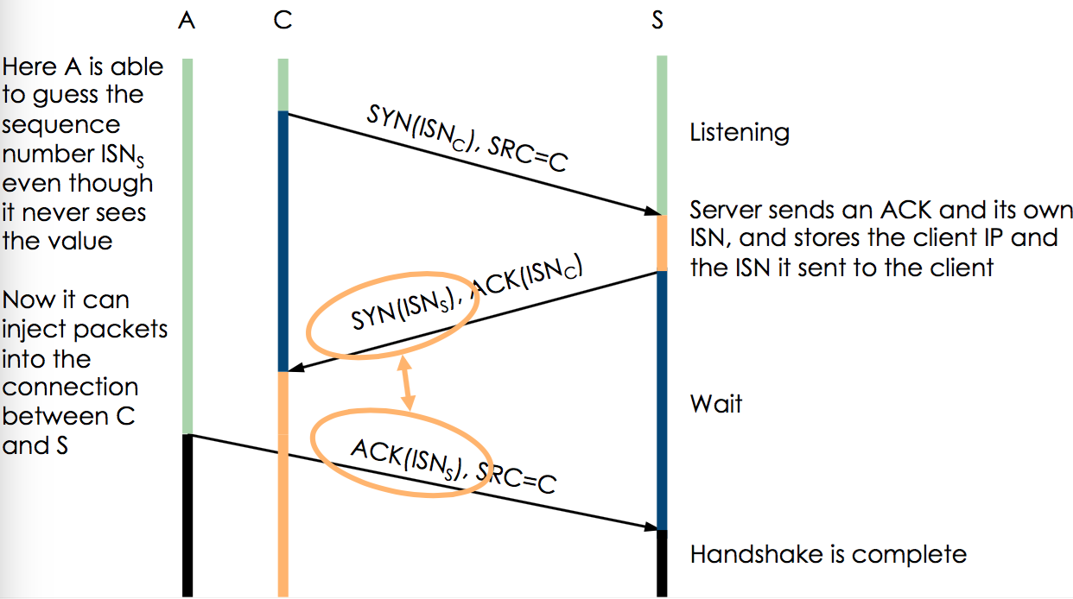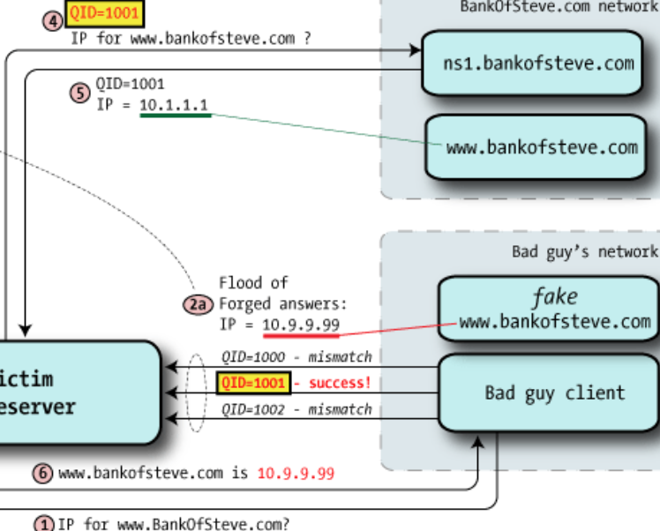

**Problem**: OSs have a fixed bound on these half-open connections the half-open connection queue resource is exhausted, no more requests (denial of service).

**Solution**: **Reduce** half-open connection timeout, **Drop** half-open connections randomly **Use SYN-ACK** cookies Client sends SYN Server responds to client with SYN-ACKcookie **ISNs = H(src addr, src port, dest addr, dest port, rand)** This is a normal response, but server does not save state. **Server regenerates** ISNs and checks that the client’s response matches ISNs

**Border Gateway Protocol (BGP):** The Internet is broken up into Autonomous Systems (AS) that are independently managed and connect to each other via gateways, the gateway routers communicate using BGP.

**Attack on BGP**: Attackers can compromise the protocol By advertising “good” routes to destinations Traffic then gets directed through attacker’s gateway. Routers trust

each other and don’t authenticate their peers, the BGP packets, or the routes advertised by the peers

**DNS:** The Domain Name System (DNS) is a hierarchicalnaming system for resources on the Internet, mapping**. Symbolic names** to numeric IP addresses

**DNS Cache Poisoning replace mapping for victim’s domain with the attacker’s IP victim domain -> attacker’s IP address**

**Host -> one time**Then it sends several DNS responses with spoofed IP addresses and various guessed Query IDs › If a spoofed response has a correct query id, the victim name server then has a poisoned www.bankofsteve.com cache

**Domain -> bankofsteve.com domain**

attack has short window of vulnerability due to caching (TTL). In this attack, the attacker performs several DNS requests for **wwwN.bankofsteve.com** to a victim nameserver where N changes with each request Then it sends several DNS responses **with a spoofed authoritative name server** If correct name server is cached, it will be evicted! If attack succeeds, attacker controls the entire bankofsteve.com domain

**Probe Phase** Attacker reads her data from the cache and times how long each read takes. Some accesses will take longer because they will miss in the cache and go to memory, and so the attacker can infer which cache lines the victim accessed between the prime and the probe phases.(D): no overlap cache, sensitive info cannot evict.

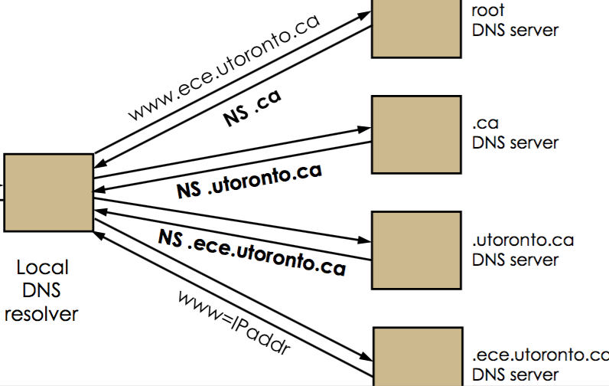

**DNS rebinding attack** replaces mapping for attacker’s

domain with victim’s IP attacker

domain -> victim’s IP address

**Attacker**: Attacker controls DNS of site,and returns DNS

response with short TTL. Attacker’s site serves a web page

with malicious script. **Browser**:The script makes are quest

to the attacker’s web site. In turn, the browser makes

another DNS query, which reaches the attacker’s DNS, since

the cached entry had a short TTL. **Attacker**: This time the

attacker’s DNS returns IP address of a victim web server

**Defense**: Browsers can pin DNS/IP mapping to the value in the first DNS response › Block resolution of external names into local IP addresses

at a local name

**Distributed DOS:** Onemethod used by an attacker is to

build up a large number of compromised hosts, and then

use them to simultaneously attack a single target

**IPSec Protocols:**

**Authenticated Headers**: Protects the IP packet (except

IP header fields that are altered during transit) using

a MAC stored in AH Header (No confidentiality)

**Encapsulating Security Payload:** Payload is encrypted

protect contents **IPSec** Message confidentiality&integrity

Source authentication Protection against replay.

**IPSec Mode: Transport** mode. Both endpoints support

IPSec. **Tunnel** mode (not support, use encapsulates)

**IPSec vs SSL:** if a specific service is required and is

supported by SSL it is better to select SSL If access to

an entire network is required, VPN software/device using

IPSec is better. SSL can provide better access control,

security, compatible with firewall, but high overhead.

**Virus insertion points: 1,** Virus overwrites the start of

program, and then inserts some fixup code to replicate

the code that it overwrote. Virus length is limited as it

can’t overwrite too much of the program before causing

problems

**2,** Virus overwrites first instruction of program with a

jump to virus code, and then jumps back to the

beginning of program

**Signatures**: Signatures should be long enough so that

legitimate code is not mistakenly identified to be infected

**Polymorphic Viruse**: Modern viruses use polymorphism,

in which a small decryption engine decrypts the rest of

the virus, Virus uses a simple encryption scheme to defeat

a signature scan, when virus propagates to a new file

To **detect polymorphic viruses**, advanced virus scanners

will run files they suspect are infected inside an emulator

**Metamorphic Viruses** change their code on every

infection by rewriting themselves, Changing register

allocations//equivalent instruction sequences //the

order of blocks of code **Detect: 1,** run in an emulator

then look for sequences of executed instructions that

indicate a virus **2**, Often viruses leave markers in infected

files so they know not to infect them again, so it may be

possible to look for these markers

**Worms: Worms** spread automatically by identifying and

exploiting vulnerabilities in hosts exploit a vulnerability

on them

Morris Worm: a main server program, and **a bootstrap**

Or **vector program**.

If successful,it created a shell on the target,uploaded

the vector (a short C program), compiled it on the target

and then ran the vector program The vector downloaded

the rest of the worm from the server, and started the

server on the newly infected

**Four vulnerabilities**: buffer overflow / sendmail system

With DEBUG option, receiving a root shell / try popular

Passwords / connect to host can log in without password

**Worm increases spreading speed**: Hit list scanning

/ local sccanning /UDP no acks, do not wait for an ACK.

**Stuxnet**: aims at Zero-Day Exploits. Lnk vulnerability,

Windows printer sharing, keyboard driver and

PLC controller.

**Stuxnet: Command & control**

Stuxnet was controlled and monitored by a central pair

Of websites. 1, Received reports of infected machines

2, Distributed updated commands/payload to the

running copies of the worms

**Botnet** is a collection of compromised machines running

malicious software under a common command- and

-control infrastructure.

**rootkit** is any software designed to hide the fact that a

system has been compromised.(Memory-based,

persistent. **User**:Intercepts library or system calls at

the user level and modifies returned results. ***Defense***: file

integrity checks bypass system call.

**Cloud computing** SaaS(software SF), Paas(Platfrom AWS),

Iass(infrasture EC2) **Hypervisors**: Low-level software

component that allows commodity compute hardware

to be virtualized and partitioned into VMs, which can

then be rented to customers. **Detect** compromised

hypervisor: TPM signs a hash of the software running at

boot (an “attestation”), to verify the integrity of the

code that’s run

**Cache Timing Exploits: Prime** The attacker fills the

shared cache with her data, thus evicting all the victim’s

data from the cache. She then lets the victim execute their

code, which uses the shared cache. Loads by the victim

will cause the attacker’s data to be evicted from the